**DATA VISUALISATION CHART**

|  |  |
| --- | --- |
| Date | 06 November 2022 |
| Team ID | PNT2022TMID43705 |
| Project Name | Project – AIRLINES DATA ANALYTICS FOR AVAITION INDUSTRY |
| Maximum Marks | 2 Marks |

A lot of extensive analysis has been carried out to gain insights from the data ingested in BigQuery while visualization has been carried in Google Data Studio.

Analysis carried out with [Google Data Studio](https://datastudio.google.com/)

* Overall flight count from Top 5 Airlines at Top 5 Airports

<iframe width="600" height="450" src="[https://datastudio.google.com/embed/reporting/a7316f10-091c-41ac-864de7538d91aaec/page/2svOB"](https://datastudio.google.com/embed/reporting/a7316f10-091c-41ac-864d-e7538d91aaec/page/2svOB) frameborder="0" style="border:0" allowfullscreen></iframe>

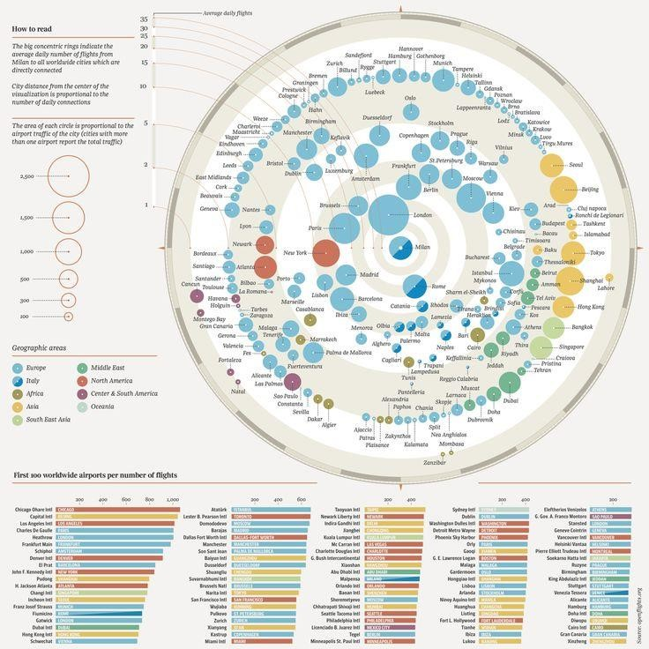

* Cancellations Pie Chart

<iframe width="600" height="450" src="[https://datastudio.google.com/embed/reporting/2f148032-7e76-407d-92c0-](https://datastudio.google.com/embed/reporting/2f148032-7e76-407d-92c0-3c04172bdd31/page/gvvOB)

[3c04172bdd31/page/gvvOB"](https://datastudio.google.com/embed/reporting/2f148032-7e76-407d-92c0-3c04172bdd31/page/gvvOB) frameborder="0" style="border:0" allowfullscreen></iframe> ---

* Overall Cancellations in Top 5 Airports

<iframe width="600" height="450" src="[https://datastudio.google.com/embed/reporting/51e8370d-1da6-4c79-bfe9-](https://datastudio.google.com/embed/reporting/51e8370d-1da6-4c79-bfe9-9163d26a6cd3/page/3xvOB)

[9163d26a6cd3/page/3xvOB"](https://datastudio.google.com/embed/reporting/51e8370d-1da6-4c79-bfe9-9163d26a6cd3/page/3xvOB) frameborder="0" style="border:0" allowfullscreen></iframe> ---

* Overall Delay in Top 5 Airports

<iframe width="600" height="450" src="[https://datastudio.google.com/embed/reporting/399ff77f-2440-478a-a336-](https://datastudio.google.com/embed/reporting/399ff77f-2440-478a-a336-4d627c3f5585/page/izvOB)

[4d627c3f5585/page/izvOB"](https://datastudio.google.com/embed/reporting/399ff77f-2440-478a-a336-4d627c3f5585/page/izvOB) frameborder="0" style="border:0" allowfullscreen></iframe> ---

* Overall Cancellation/Delays Yearwise

<iframe width="600" height="450" src="[https://datastudio.google.com/embed/reporting/d4be53fe-6928-4e6c-89d0e23aac599be8/page/45vOB"](https://datastudio.google.com/embed/reporting/d4be53fe-6928-4e6c-89d0-e23aac599be8/page/45vOB) frameborder="0" style="border:0" allowfullscreen></iframe> --- - Overall Yearwise Cancellations <iframe width="600" height="450" src="[https://datastudio.google.com/embed/reporting/7b267dde-41fc4e1c-b292-9b5da5ea7b0d/page/U7vOB"](https://datastudio.google.com/embed/reporting/7b267dde-41fc-4e1c-b292-9b5da5ea7b0d/page/U7vOB) frameborder="0" style="border:0" allowfullscreen></iframe> ---

* Overall Cancellation

[Reason](https://github.com/aroraayush/Kaggle-Airline-Data-Analysis/blob/master/images/7_Cancellation_Reason_bifurcation.png)

[s](https://github.com/aroraayush/Kaggle-Airline-Data-Analysis/blob/master/images/7_Cancellation_Reason_bifurcation.png)

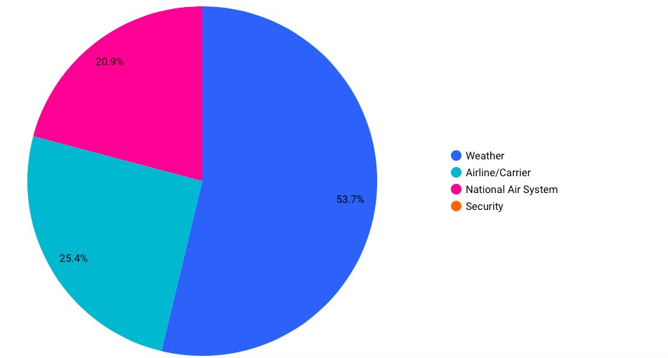

* Overall Cancellation Reasons (Busiest Airport - Atlanta)

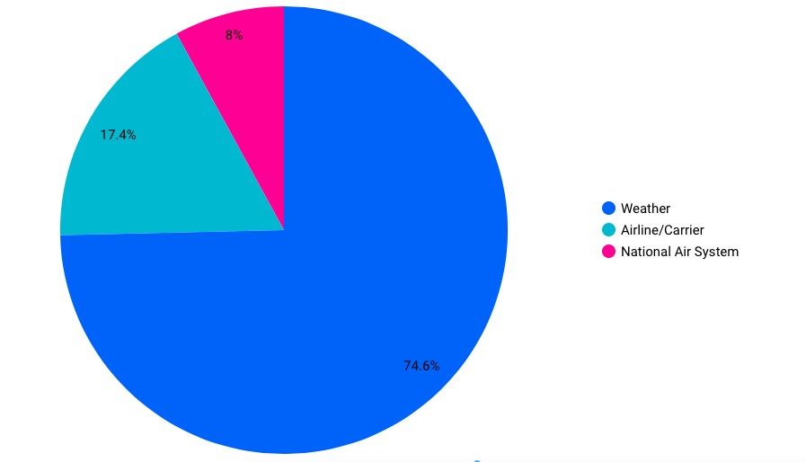

* Delay Count

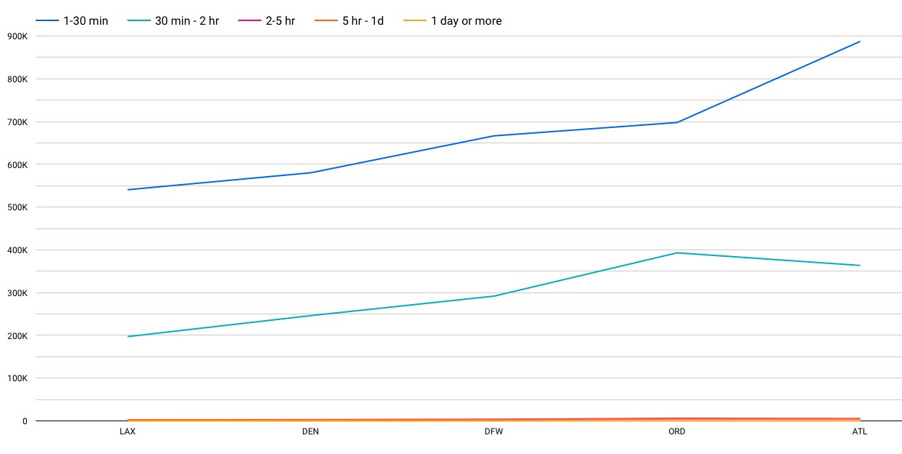

* Delay Count

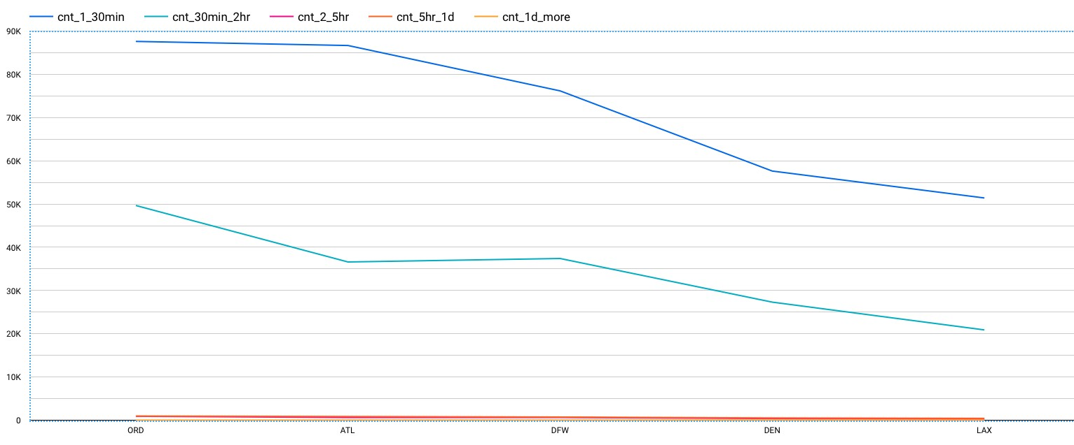

* Delay Percentage for top 5 airports

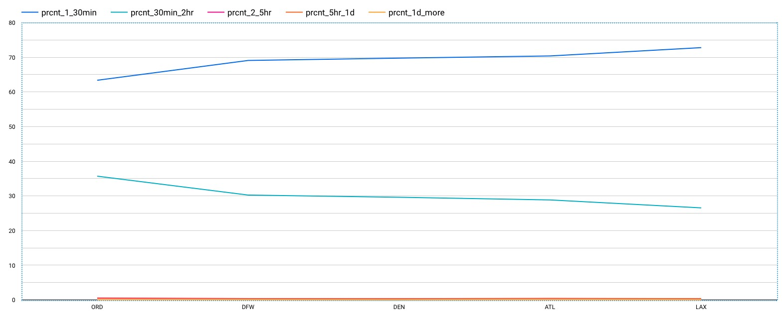

* Delay Percentage for top 5 airports



* Most unreliable month in 2021(Cancellations in ascending order)

